ST USB MIDDLEWARE

TERMINOLOGIES :
Abbreviation | Term
HID | Human Interface Device
CDC | Communications Device Class
DFU | Device Firmware Upgrade
MSC | Mass Storage Class
HAL_PCD | Peripheral Controller Driver
HAL | Hardware Abstraction Layer
MSP | MCU Support Package
NVIC | Nested Vectored Interrupt Controller
IRQ | Interrupt Request

STM32 USB Middleware
STM32 USB middleware is a set of software libraries provided by STMicroelectronics to simplify the development of USB applications on STM32 microcontrollers. It includes a range of features and support for various USB classes, making it easier to implement USB functionality in embedded systems.
- USB Device Library:
  - Provides support for USB device mode.
  - Includes standard USB classes such as Human Interface Device (HID), Mass Storage Class (MSC), Communication Device Class (CDC), and Audio.
- USB Host Library:
  - Provides support for USB host mode.
  - Supports USB hubs and multiple device connections.
  - Includes host class drivers for HID, MSC, and other standard USB classes.

1-STM32 as a Device
this is what you need to focus on : The project is based mainly on Middlewares folder and USB_Device folder.. . The project is based on two folders: the Middleware folder, which contains core USB stack and class files (used automatically, not modified by users in most basic cases ), and the USB_DEVICE folder, where user-specific application logic is implemented based on the chosen mode (Device/Host) and class (CDC, HID, etc.).
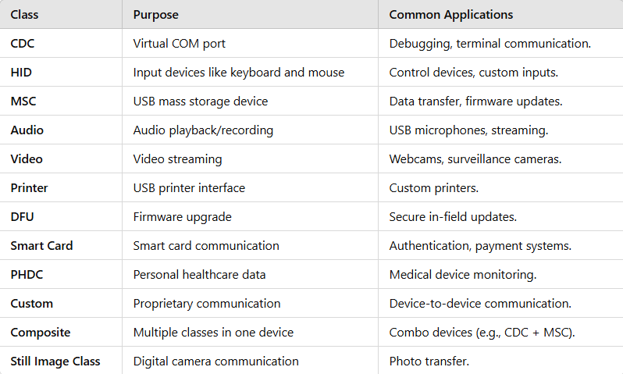
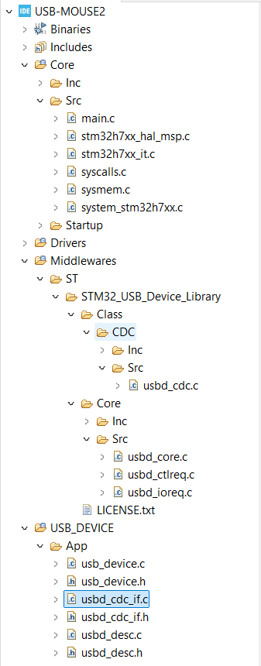
Here is the general structure of a STM32 project as USB device.(folder names depends on the chosen classes but files are generally the same no matter what class are you using

MIDDLEWARE FOLDER :
COMMON FILES
In the USB stack there are some files that you gonna find in every stm32 usb project . they are part of the project structure. they are a necessity so the compiler could build your project and link your main.c with your USB folder _device files . your not gonna use these files most of the time but its very helpful if you understand how they work specially if you are a developer not just a user . were are going to explain them a little bit (their purpose and some need to know functions) like :
1. usbd_core.c/h
Purpose:
- Manages the core USB device functionality, such as device initialization, state transitions, and handling USB events.
When You Need It:
- Always! This file is the backbone of any USB device implementation but you won’t modify on it
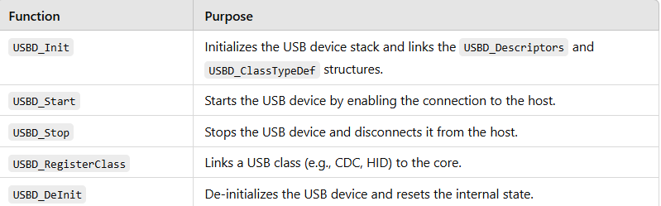
2. usbd_ctlreq.c/h
Purpose:
- Handles control requests sent by the USB host during enumeration or runtime.
- It implements the standard USB control transfers, such as GET_DESCRIPTOR, SET_ADDRESS, or GET_CONFIGURATION.
When You Need It:
- Always! Control requests are part of every USB class (used during device enumeration and configuration). but you won’t modify on it
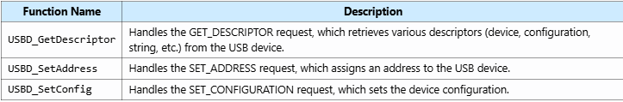
4. usbd_desc.c/h
Purpose:
- Contains the device descriptors, configuration descriptors, and string descriptors.
- These descriptors define the device’s identity, capabilities, and configurations to the USB host.
When You Need It:
- Always! Without proper descriptors, the USB host cannot recognize or enumerate the device. but you won’t modify on it
Important Functions:
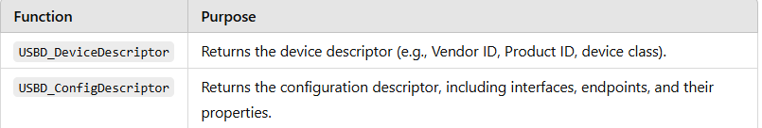
1. usbd_device.c
Purpose:
- This file is specific to your USB project and links together the USB Device Core (usbd_core.c) and the USB class you're implementing (e.g., CDC, HID, MSC).
It is responsible for:
- Registering the USB class (e.g., CDC, HID, MSC, etc.).
- Initializing the USB device core.
- Starting the USB device stack.
- Linking your application-specific logic to the USB middleware.
Important Functions:
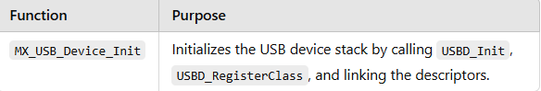

GENERAL FUNCTIONS /
Functions
NOW there are some functions that you are going to find in every USB device class
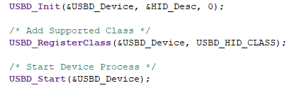
The rest of the files are based on the used class :

Call sequence :USBD_init() :
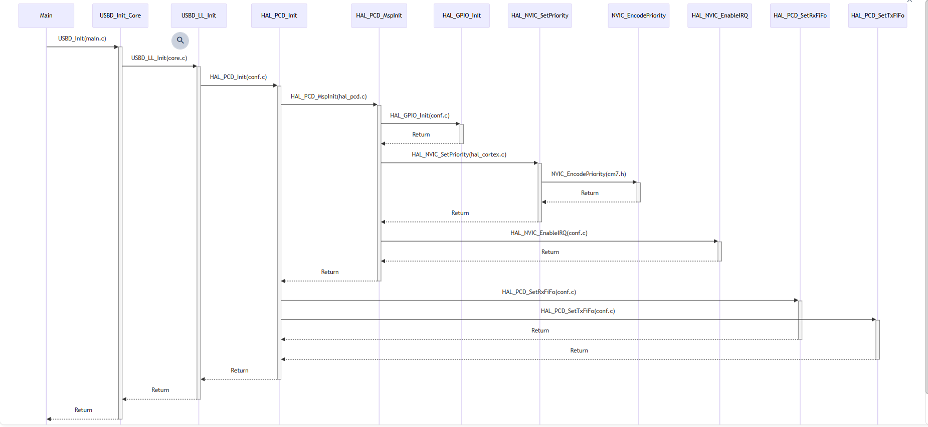
Explanations
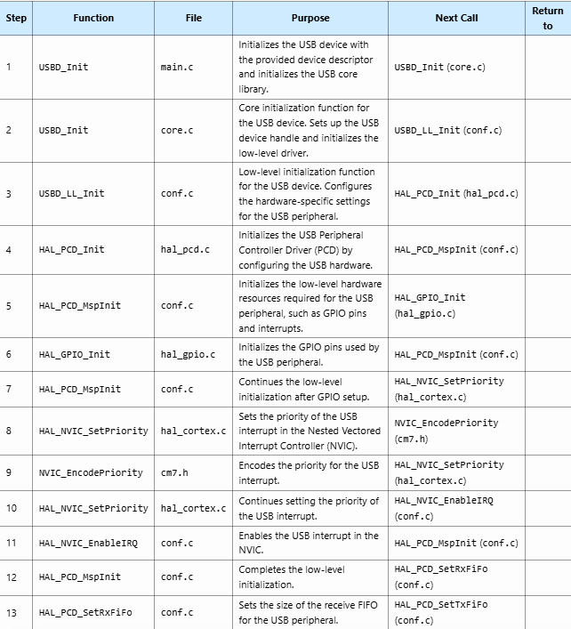
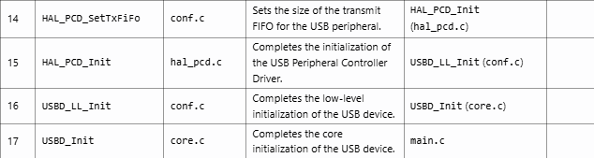

USBD_REGISTERCLASS
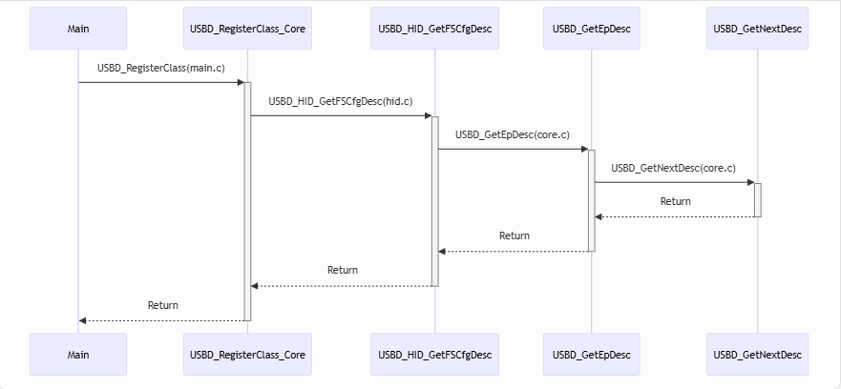

Explanations
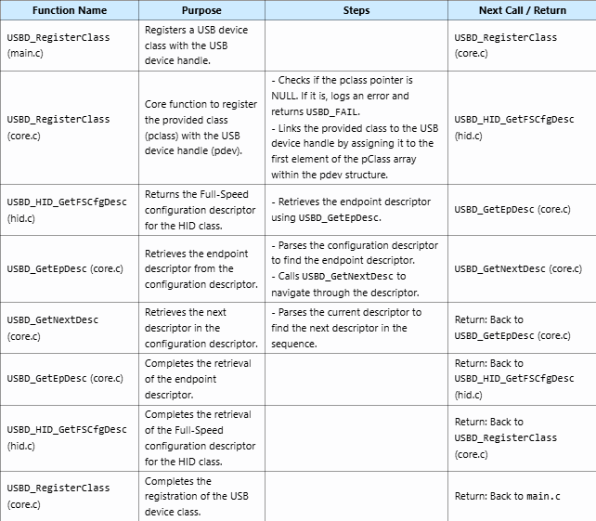
enregistrement de class utilisée en vérifiant l’état du pointer spécifique d’abord puis un échange de descripteurs

USBD_START
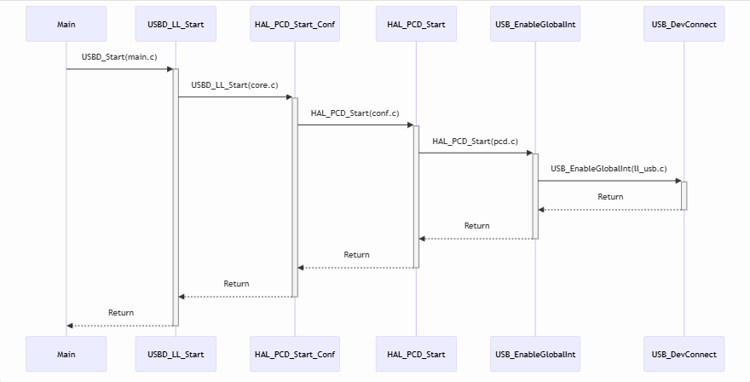

Explanations
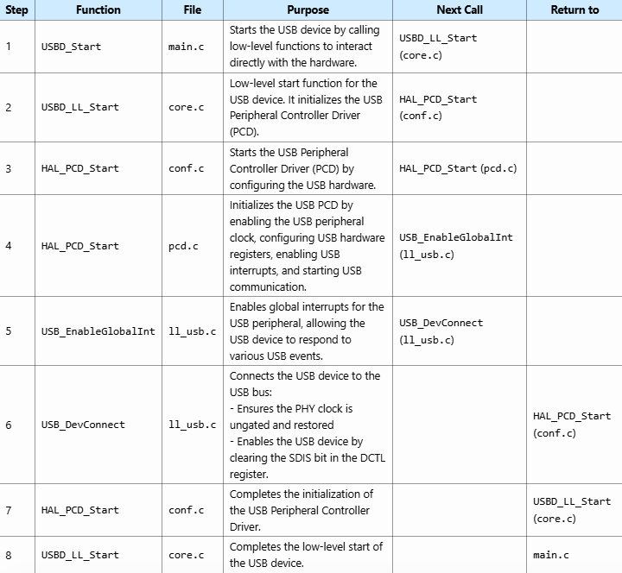

NOW there are some files that are specific to each class (they generally have specific) functions for the class selected also)
HID_CLASS :
Purpose of usbd_hid.c File
The usbd_hid.c file is part of the USB Device library for STM32 microcontrollers. It provides the core functions for managing the USB Human Interface Device (HID) class. This includes initialization, configuration, handling enumeration as an HID device, managing data transfers, handling class-specific requests, and error management.
When You Will Need It and Modify It
You will need to use and potentially modify the usbd_hid.c file when developing a USB device application that requires HID functionality, such as a USB mouse, keyboard, joystick, or any custom HID device. Modifications to this file might include:
- Customizing the handling of HID class-specific requests
- Implementing application-specific data processing in the data IN and OUT functions
- Adjusting buffer sizes and data handling mechanisms to fit your application's requirements
- Modifying the HID report descriptor to match the specific HID device you are implementing
Most Important Functions in usbd_hid.c
Here are the most important functions in the usbd_hid.c file, along with their descriptions:
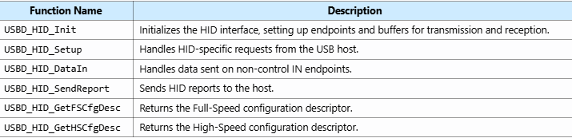
CDC CLASS
- usbd_cdc_if.c

Purpose
The usbd_cdc_if.c file is part of the USB Device library for STM32 microcontrollers. It provides the implementation of the USB Communication Device Class (CDC) interface, which allows the USB device to function as a Virtual COM Port (VCP). This enables the USB device to emulate a serial port over USB, allowing communication with a host computer using standard serial communication protocols.

When You Will Need It
You will need to use and potentially modify the usbd_cdc_if.c file when you are developing a USB device application that requires a Virtual COM Port functionality. This is common in applications where you need to transfer data between the STM32 microcontroller and a host computer via USB.
Modifications to this file might include:
- Customizing the handling of CDC class-specific requests
- Implementing application-specific data processing in the receive and transmit functions
- Adjusting buffer sizes and data handling mechanisms to fit your application's requirements
Use Cases:
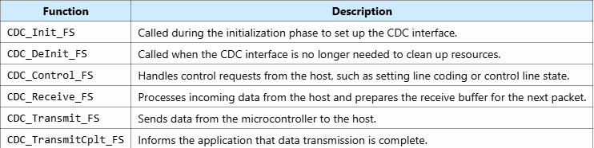
usbd_cdc.c
he usbd_cdc.c file is part of the USB Device library for STM32 microcontrollers. It provides high-level firmware functions to manage the USB Communication Device Class (CDC). This includes initialization, configuration, handling enumeration as a CDC device, managing data transfers, handling class-specific requests, and error management.

When You Will Need It and Modify It
You will need to use and potentially modify the usbd_cdc.c file when developing a USB device application that requires CDC functionality, such as a Virtual COM Port. This is common in applications where you need to transfer data between the STM32 microcontroller and a host computer via USB, such as:
Most Important Functions in usbd_cdc.c
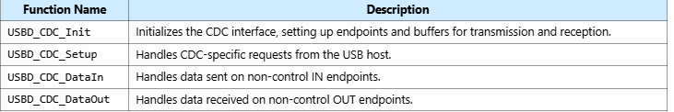

MSC CLASS device
Important files :
- usbd_msc_bot.c: Implements the Bulk-Only Transport (BOT) protocol for communication between the host and the device.
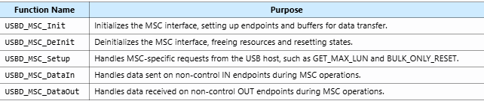
- usbd_msc_data.c: Contains data structures and definitions used by the MSC class, including SCSI command definitions and inquiry data.
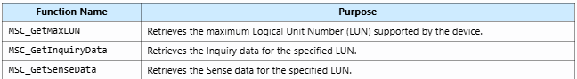
- usbd_msc_scsi.c: Implements the SCSI command set, processing commands and handling data transfer.
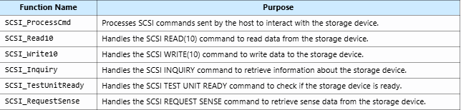
- usbd_msc.c: Contains the core implementation of the MSC class, integrating the BOT and SCSI layers and handling USB events.
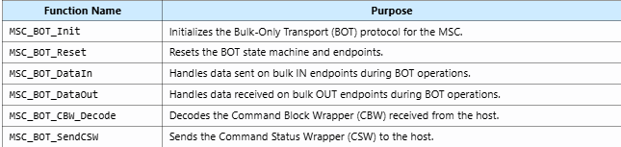
Storage_if.c :
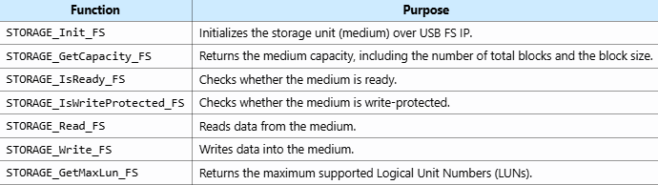
Verification function :
USBD_MSC_RegisterStorage(&USBD_Device, &USBD_DISK_fops);
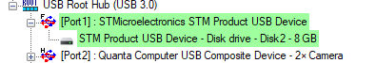

DFU CLASS
Function added
USBD_DFU_RegisterMedia(&USBD_Device, &USBD_DFU_Flash_fops);
A verification function

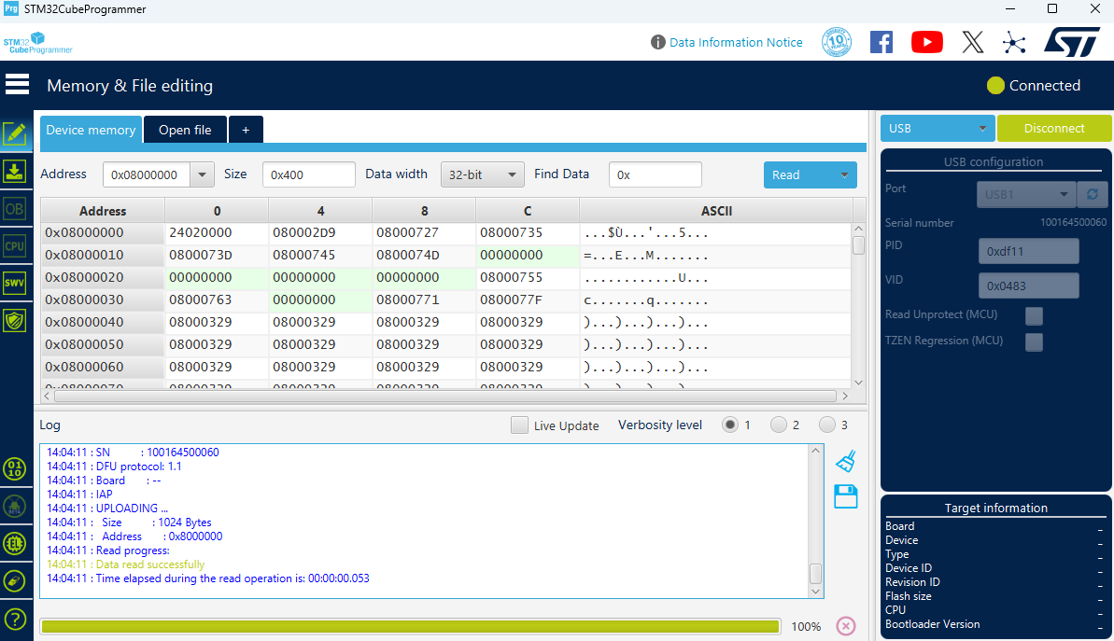 Purpose of usbd_dfu.c File
The usbd_dfu.c file is part of the USB Device library for STM32 microcontrollers. It provides the core functions necessary to implement the USB Device Firmware Upgrade (DFU) class. The DFU class allows the microcontroller's firmware to be updated via USB without the need for an external programmer. This file handles DFU-specific requests, manages data transfers, and performs firmware updates.
When You Will Need It and Modify It
You will need to use and potentially modify the usbd_cdc.c file when developing a USB device application that requires CDC functionality, such as a Virtual COM Port. This is common in applications where you need to transfer data between the STM32 microcontroller and a host computer via USB, such as:
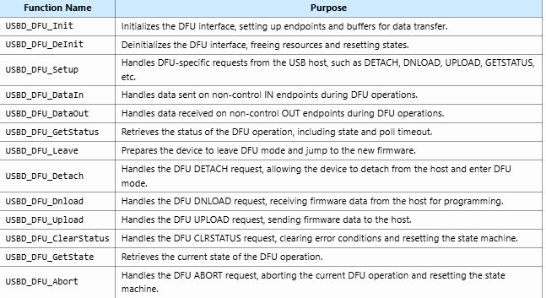

Most important functions in this file "usbd_dfu_if.c"
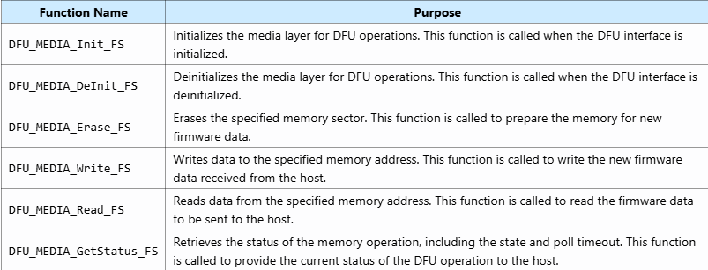

AUDIO
USBD_AUDIO_RegisterInterface(&USBD_Device, &USBD_AUDIO_fops);
Fonction de verification
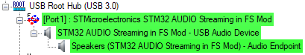
Purpose of audio.c File in Audio Class
The audio.c file is part of the USB Device library for STM32 microcontrollers, specifically for implementing the USB Audio Class. This file provides the core functions necessary to handle audio data transfer between the USB host and the audio device. It manages the initialization, configuration, and data transfer for audio streaming, ensuring that audio data is correctly processed and transmitted.
Table of Most Important Functions in USBD_audio.c
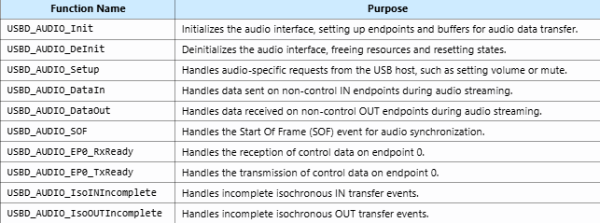
Most important function in USBD_audio_if.c

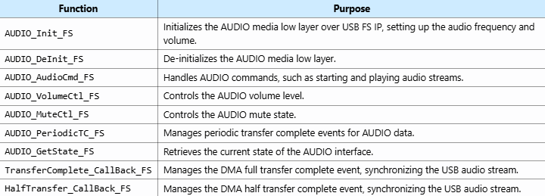

STM32 AS A HOST
There are some files that you gonna find in each stm32 host project like :
- usbh_core.c:
  - Purpose: This file contains the core functions of the USB Host library. It manages the overall USB host state machine, initialization, deinitialization, and the main process loop.
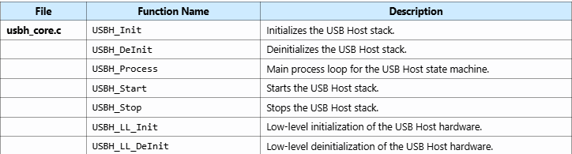
- usbh_ctlreq.c:
  - Purpose: This file handles control requests. It implements the standard USB control transfer protocol, including setup, data, and status stages.
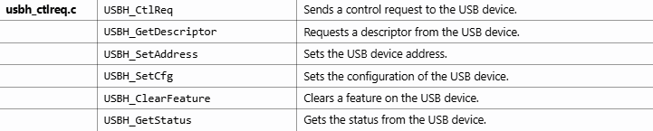
- usbh_ioreq.c:
  - Purpose: This file manages I/O requests. It provides functions for handling different types of USB transfers such as control, bulk, interrupt, and isochronous transfers.
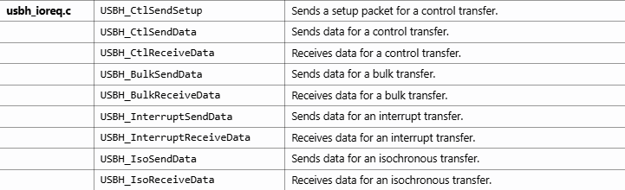
- usbh_pipes.c:
  - Purpose: This file manages the USB host pipes (also known as channels of EndPoint). It includes functions to open, close, and manage the state of the pipes used for communication with USB devices.
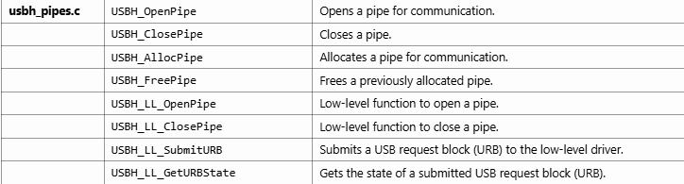
Purpose of usbh_conf.c
The usbh_conf.c file serves the following purposes:
- Hardware Configuration: Initializes and configures the USB hardware, including GPIOs, clocks, and interrupts.
- Low-Level Driver Interface: Provides low-level functions that interface with the hardware controller driver (HCD) to perform USB operations.
- Callback Functions: Implements callback functions for handling USB events such as connection, disconnection, and URB state changes.
- Utility Functions: Provides utility functions for managing USB host operations, such as setting and getting pipe toggles, driving VBUS, and handling delays.

Key Functions in usbh_conf.c
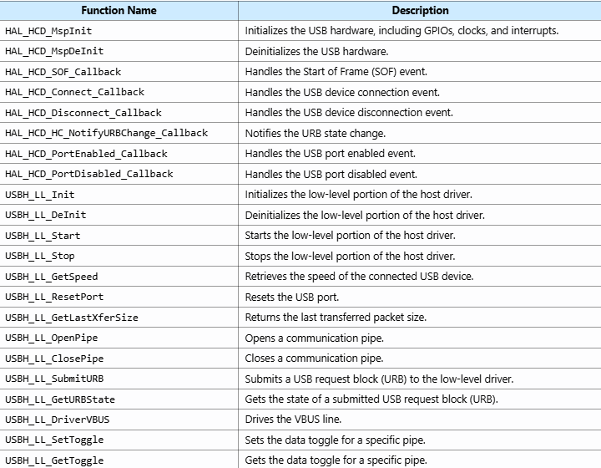
** in most of the cases : functions of the above files are used automatically to handle the project . you will use them . most of the functions that you gonna use and call are in files underneath
Purpose of usb_host.c
The usb_host.c file serves the following purposes:
- Initialization: Initializes the USB host library, registers supported USB classes, and starts the USB host stack.
- Main Process Loop: Provides the main process loop for handling USB host events and state changes.
- User Callbacks: Implements user-defined callback functions to handle various USB events such as connection, disconnection, and class activation.
Key Functions in usb_host.c
Here is a summary of the most important functions in usb_host.c:
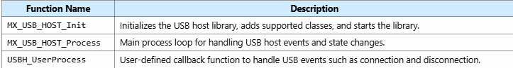
FUNCTIONS:
USBH_init :
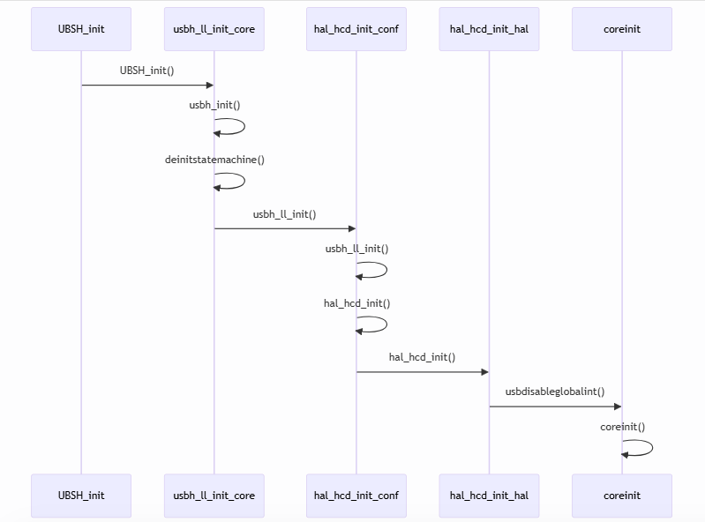

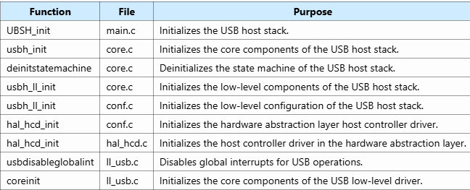
-USBH_START :
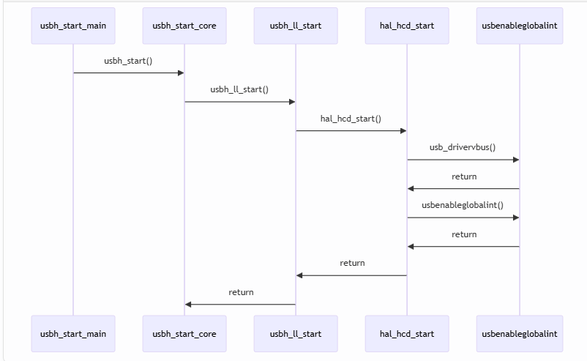
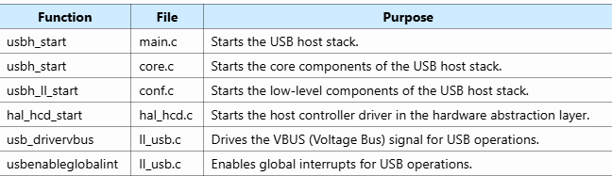-

USBH_registerclass core.c then back to main.c to just verify number of max of supported classes
USBH_Process : Purpose: The USBH_Process function handles the various states of the USB Host and processes events such as device connection and disconnection.

And there are some files and functions that are specific for the chosen class
HID_CLASS
the usbh_hid.c file is part of the USB Host HID class library in STM32 firmware. It implements the core handlers for managing HID (Human Interface Device) class devices, such as keyboards and mice. This file includes functions for initializing the HID interface, handling class-specific requests, managing data transfers, and parsing HID descriptors.
Purpose of usbh_hid.c
The usbh_hid.c file serves the following purposes:
- Interface Initialization: Initializes the HID interface, setting up necessary data structures and endpoints.
- Class Requests: Handles class-specific requests for HID devices, such as getting and setting reports.
- Data Processing: Manages the state machine for HID data transfers, including receiving and processing HID reports.
- Descriptor Parsing: Parses HID descriptors to extract relevant information about the HID device.
Key Functions in usbh_hid.c
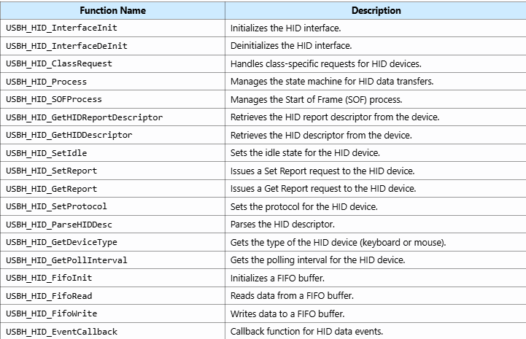
Purpose of usbh_hid_keybd.c
the usbh_hid_keybd.c file is part of the USB Host HID class library in STM32 firmware. It implements the application layer for handling USB HID keyboards, supporting both QWERTY and AZERTY layouts. This file includes functions for initializing the keyboard, decoding keyboard data, and converting it into ASCII characters.
Purpose of usbh_hid_keybd.c
The usbh_hid_keybd.c file serves the following purposes:
- Initialization: Initializes the HID keyboard, setting up necessary data structures and buffers.
- Data Decoding: Decodes the HID reports received from the keyboard and extracts key press information.
- ASCII Conversion: Converts the decoded key press information into ASCII characters for easy use in applications.
Key Functions in usbh_hid_keybd.c
Here is a summary of the most important functions in usbh_hid_keybd.c:
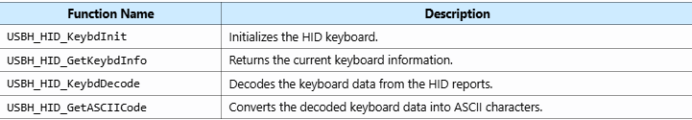
the arrays like HID_KEYBRD_ShiftKey in the usbh_hid_keybd.c file is a lookup table used to map USB HID key codes to their corresponding ASCII characters when the Shift key is pressed
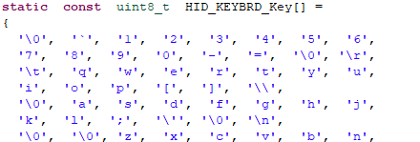
The HID_Report_ItemTypedef structures defined in the usbh_hid_keybd.c file represent individual items in a HID (Human Interface Device) report. These structures are used to describe the properties of specific fields within the HID report, such as the state of modifier keys (e.g., Ctrl, Shift, Alt, GUI) and key arrays for a keyboard.
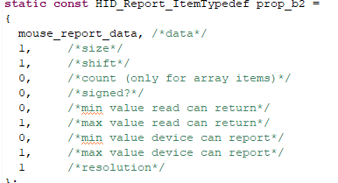
Purpose of usbh_hid_mouse.c
The usbh_hid_mouse.c file serves the following purposes:
- Initialization: Initializes the HID mouse, setting up necessary data structures and buffers.
- Data Decoding: Decodes the HID reports received from the mouse and extracts information such as button states and cursor movement.
- Information Retrieval: Provides functions to retrieve the current state of the mouse, including button states and cursor movement.
Key Functions in usbh_hid_mouse.c
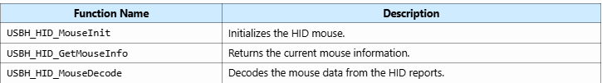

The usbh_hid_parser.c file is part of the USB Host HID class library in STM32 firmware. It implements the HID (Human Interface Device) parser, which is responsible for reading and writing HID report items( report item specifies the properties of a particular piece of data, such as its size, type, part of the HID report). This file includes functions for extracting data from HID reports and writing data to HID reports.
Purpose of usbh_hid_parser.c
The usbh_hid_parser.c file serves the following purposes:
- Reading Report Items: Provides functions to read specific items from HID reports, such as button states or cursor movement.
- Writing Report Items: Provides functions to write specific items to HID reports, allowing for control of HID devices.
- Data Conversion: Handles the conversion of logical values to physical values and vice versa, ensuring that data is correctly interpreted and manipulated.
Key Functions in usbh_hid_parser.c
Example of, code for mouse and keyboard :
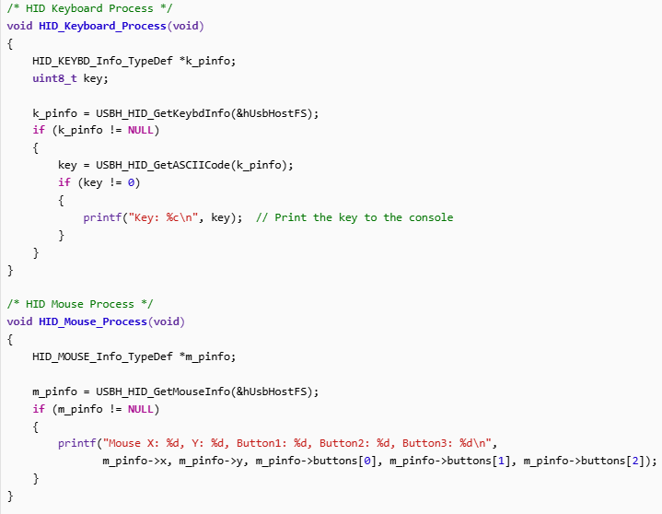

CDC_CLASS
The usbh_cdc.c file is part of the USB Host CDC (Communications Device Class) class library in STM32 firmware. It implements the core handlers for managing CDC class devices, such as USB-to-serial adapters. This file includes functions for initializing the CDC interface, handling class-specific requests, managing data transfers, and processing CDC-specific commands.
Purpose of usbh_cdc.c
The usbh_cdc.c file serves the following purposes:
- Interface Initialization: Initializes the CDC interface, setting up necessary data structures and endpoints.
- Class Requests: Handles class-specific requests for CDC devices, such as getting and setting line coding.
- Data Processing: Manages the state machine for CDC data transfers, including sending and receiving data.
- Descriptor Parsing: Parses CDC descriptors to extract relevant information about the CDC device.
Key Functions in usbh_cdc.c
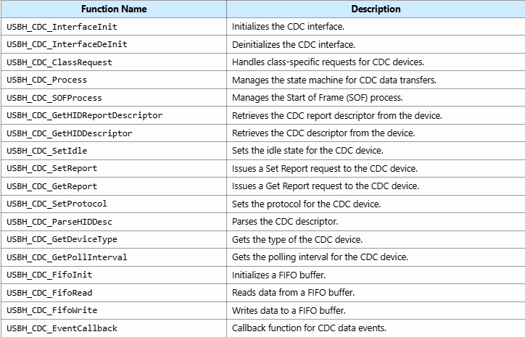

MSC CLASS
Mass Storage Class (MSC)
This class code is implemented to access and communicate with USB Mass Storage devices based on the “Bulk-Only Transport” (BOT) protocol and the SCSI command set. This class folder includes:
- usbh_msc (.c, .h): these files include the common MSC class’ variables and specific APIs implementation. The following table shows the main functions.
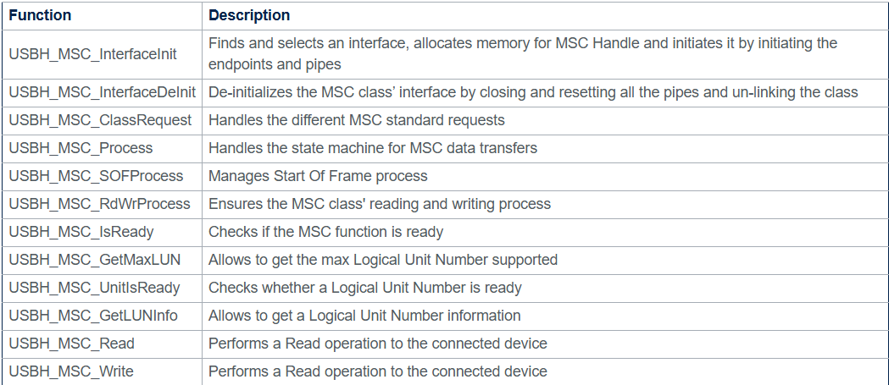
- usbh_msc_bot(.c, .h): these files include the USB “Bulk-Only Transport” BOT protocol implementation. The following table shows the main functions.
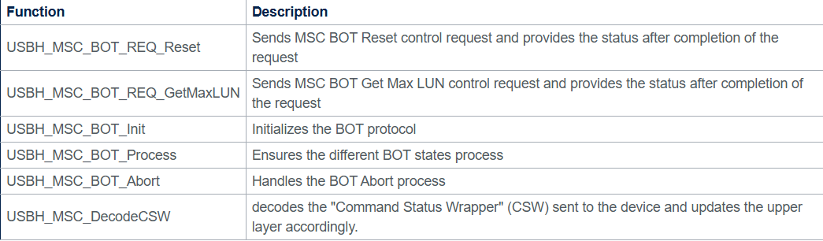
- usbh_msc_scsi(.c, .h): these files include the SCSI(Small Computer System Interface.) commands implementation. The following table shows the main functions.
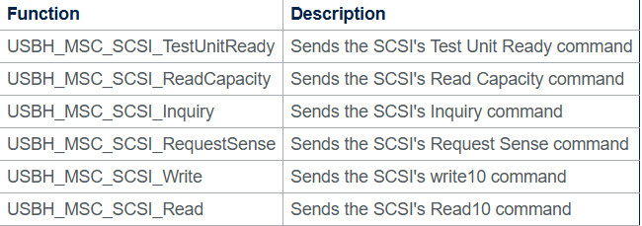

AUDIO Class (AC)
This class code is implemented to access and communicate with the USB speaker device that is compliant with the USB Audio class 1.0 specification. This class folder includes:
- usbh_audio (.c, .h): these files include the common CDC class variables and specific APIs implementation. The following table shows the main functions.
